

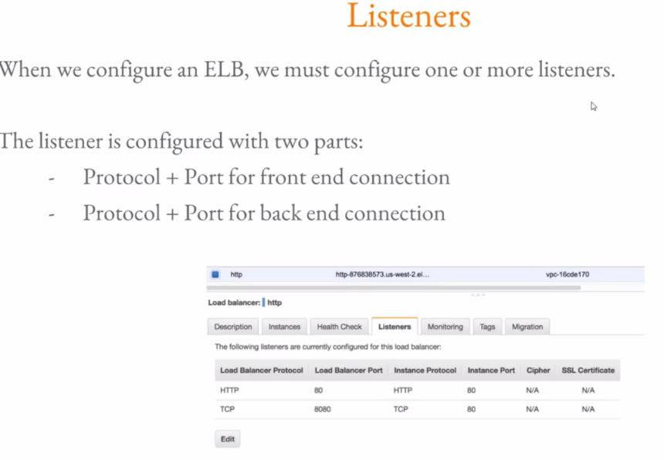

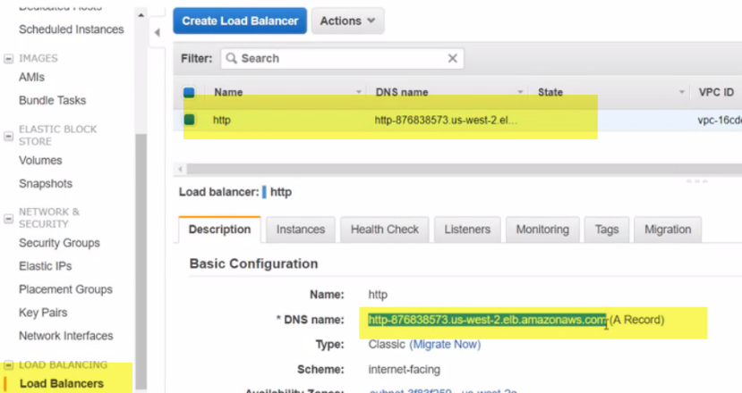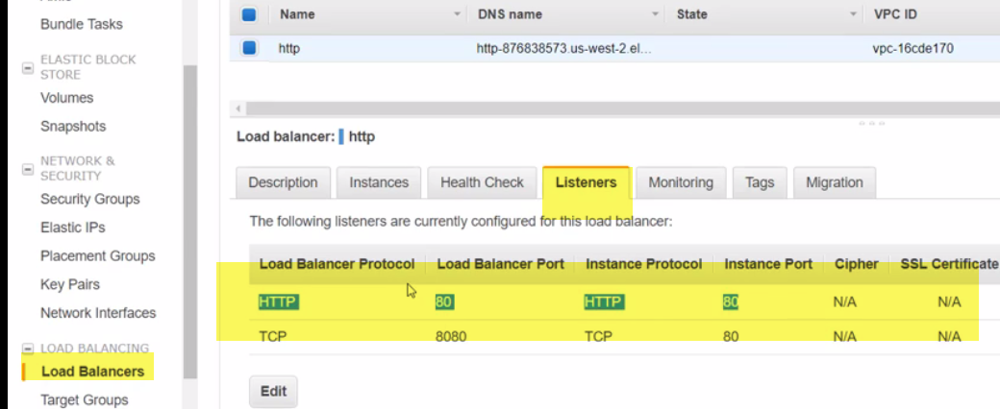

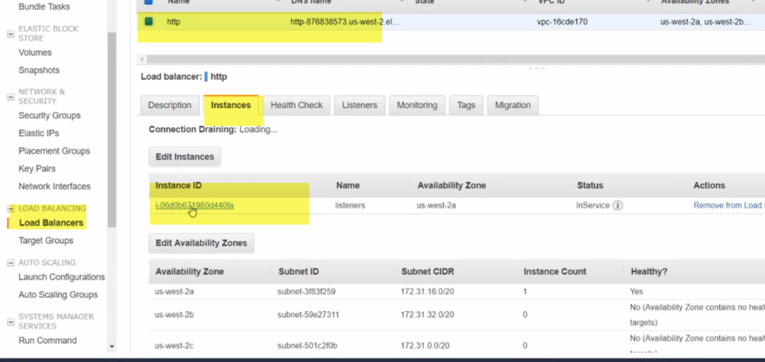

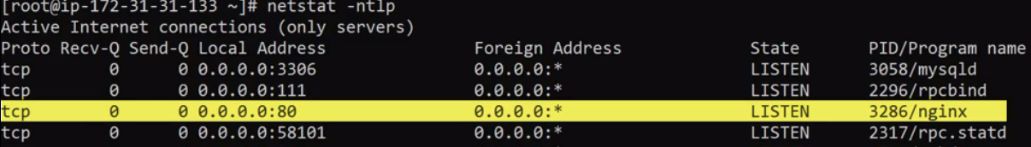

If I have nginx on port 8080, I have to change backend listener to port 8080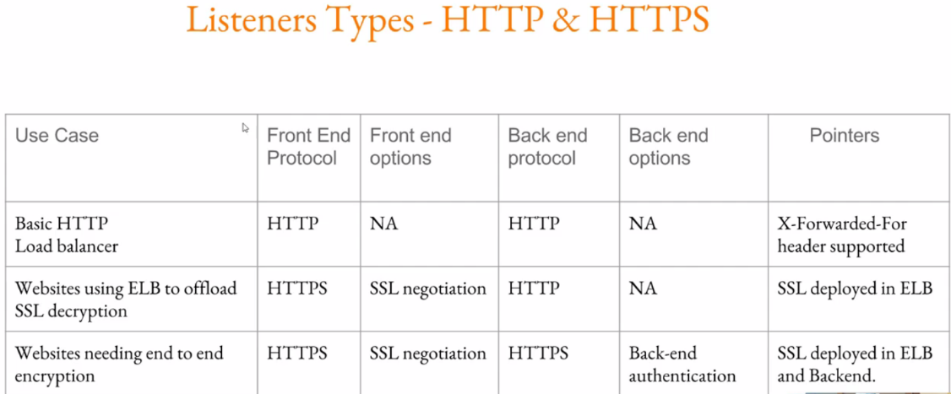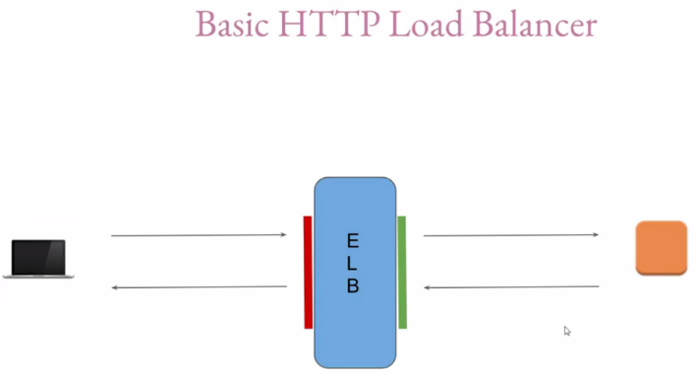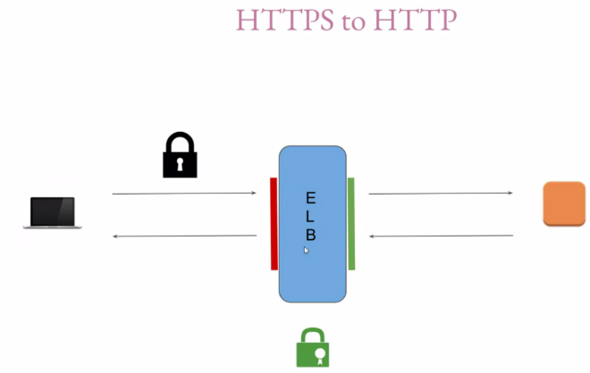

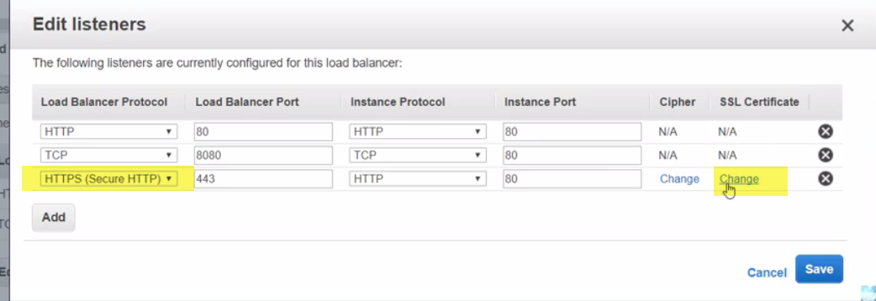

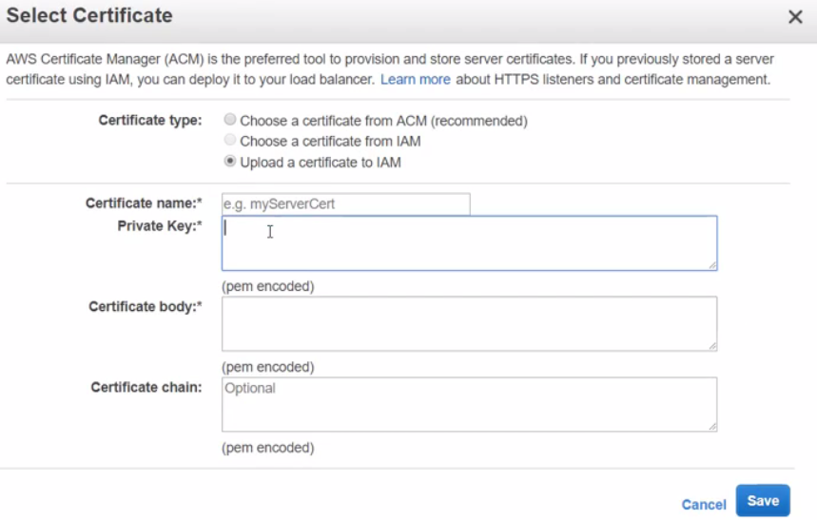

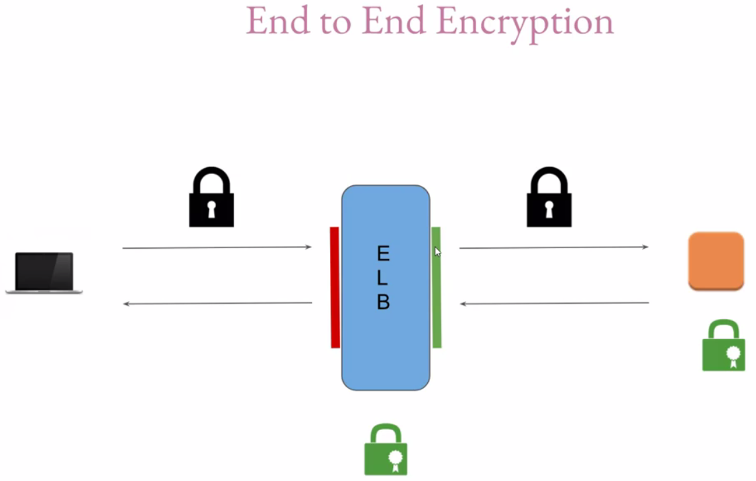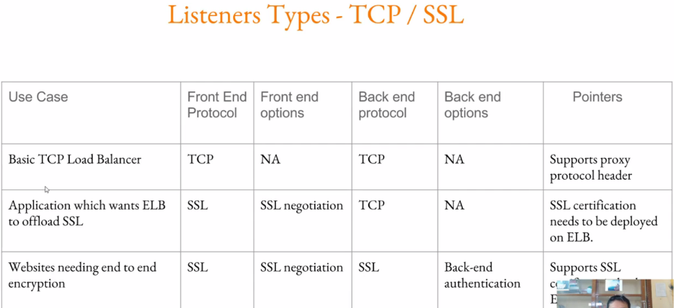

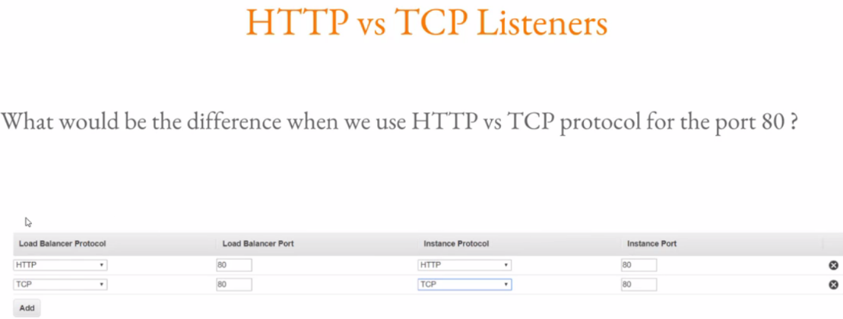

1. When client sends request to ELB, request is http request with certain headers of http protocol.
2. ELB will initiate new connection to backend instance(same connection is not forwarded).
3. The request that ELB send to backend instance, there are more headers…Headers are being added by ELB.
4. Then ELB will responds back ad send request to client.

**ELB modify http headers which have been sent by client to the server.**

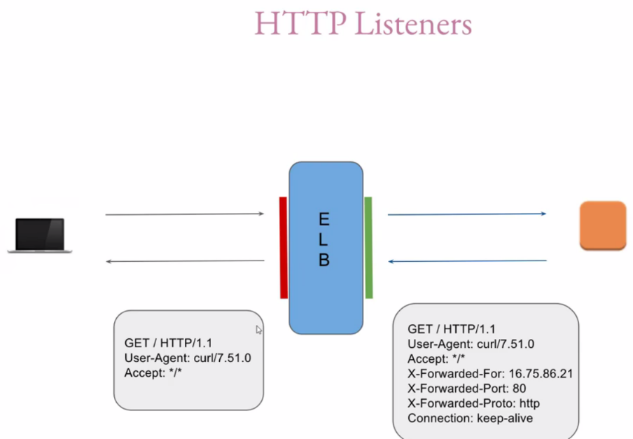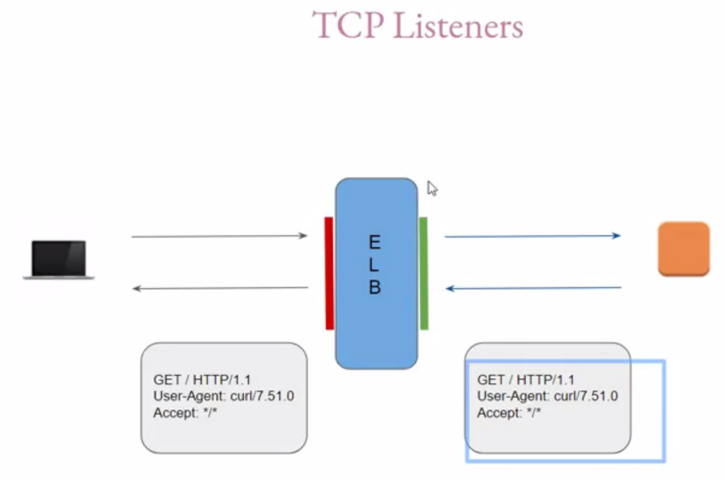

1. Request header will not be modified by ELB. It will fwd same request received form the cleint to EC2 instances running behind the elb.

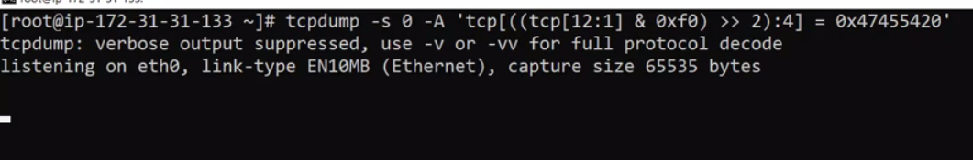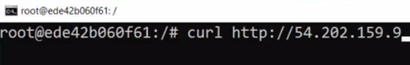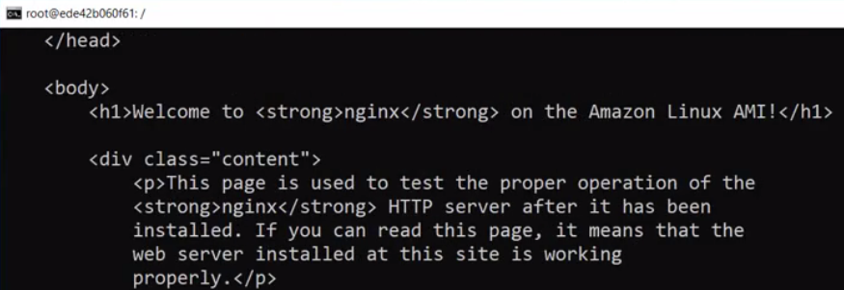 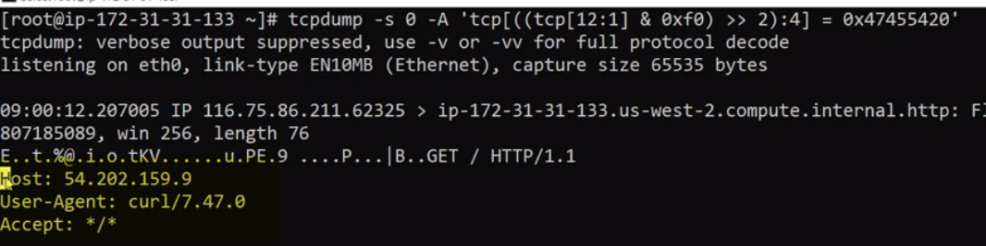

Output is simple get request on HTTp-1.1.

Headers are related to host,user-agent and accept.

This is when we make direct connection to EC2 instance.

Start tcpdump again

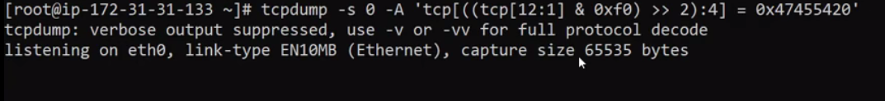

Here, instead of sending traffic to Ec2 instance, send it to ELB.

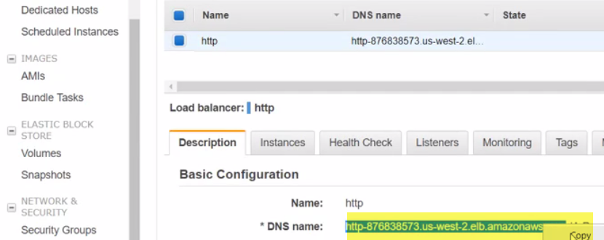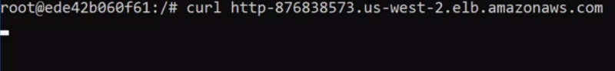 

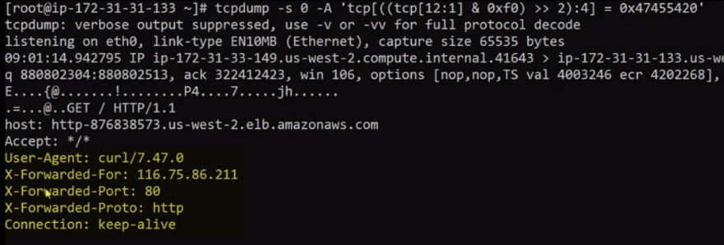

This is request received from ELB. 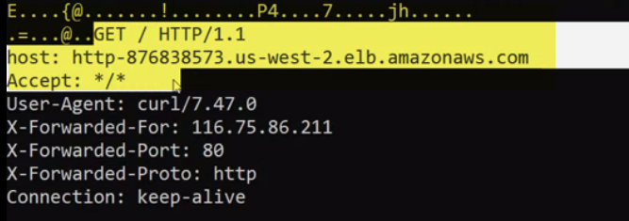

These headers are resent earlier also..., **when we made direct connection**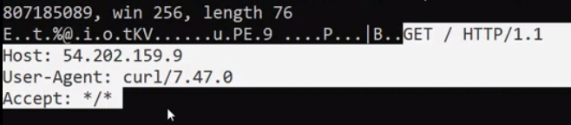

**When we initiate connection via ELB, there are certain headers which RE ADDED BY elb**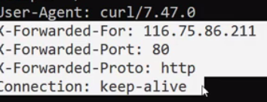

**Tcp LISTERNERS**

**doesn’t ADD HEADERS,passed by client.\**

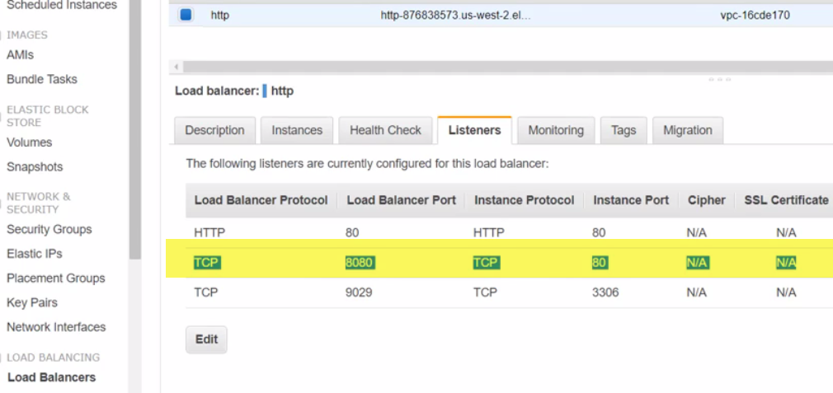 

Run curl here, on port 8080 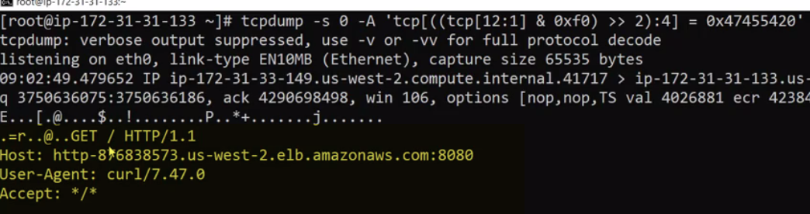

Headers are exactly same.ELB doent add any forwareded or any here..

WHATEVER HEADER SENT BY CLIENT, SAME IS FWDED TO THE EC2 by ELB.

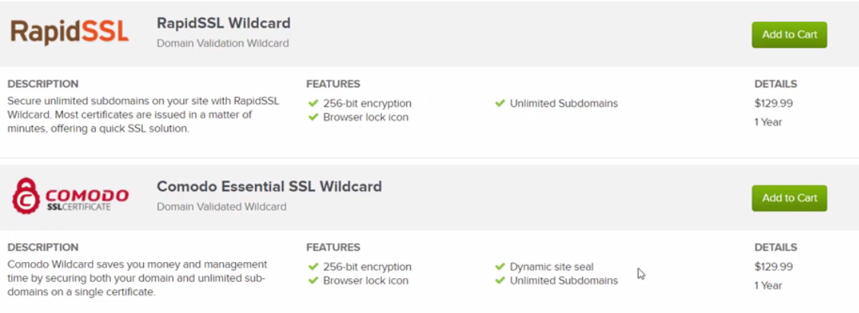

SSl ON ELB

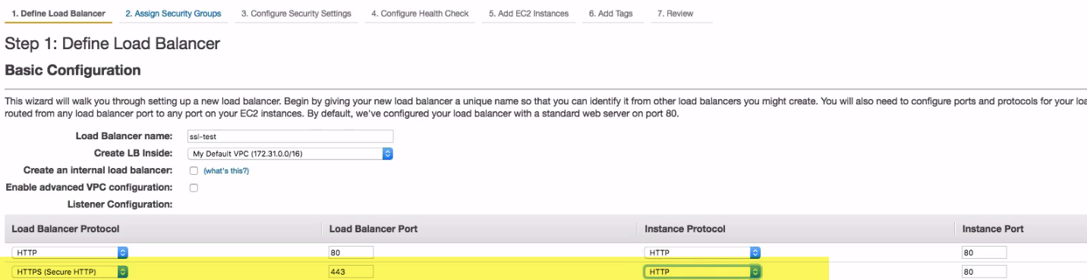

Thirdparty:

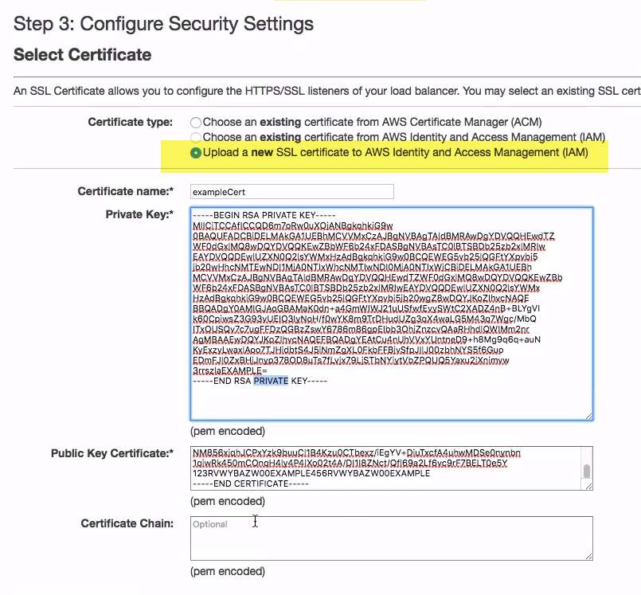

Select latest Cipher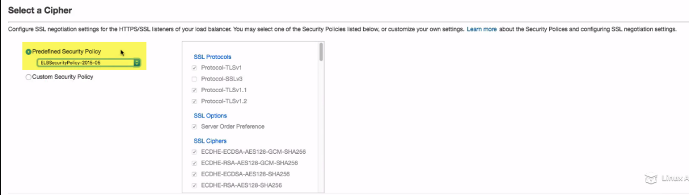

**Default ELB**

ELB Deployment Scenarios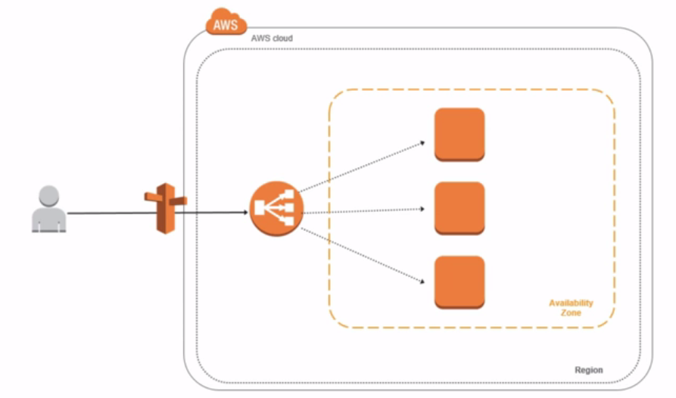

1.)the default one, the very simple one is that with the load balancer when you deploy ELB, your users, if it's exposed to the internet, again if this is---an elastic IP address has been assigned to the load balancer, which means the users can hit it from the outside world, it'll go through Route 53 or your DNS and it'll point to that elastic load balancer.

2.)That elastic load balancer will then load balance instances that are available to it in a particular availability zone. 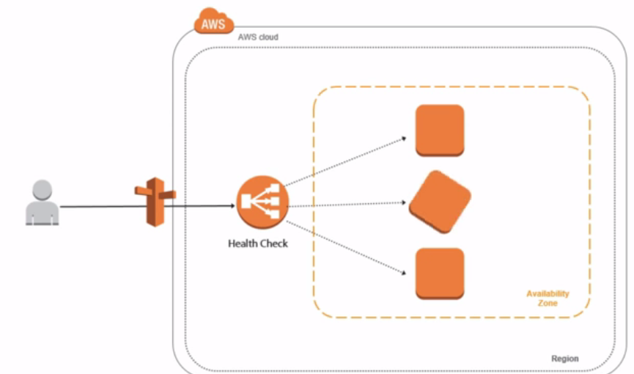

3.)Now if you have health check enabled, for example, it will determine if a particular instance is not performing properly. If a particular instance is not performing properly, it will remove it out of rotation. It will only add it back into rotation when this particular instance can prove that it is now healthy. The way to prove that it is healthy depends on how you have configured it.

If you've configured it based on metrics to say if the instance has CPU of 80%, take it out of rotation, that essentially translates into the instance requiring to fall below 80% before you add it back into rotation.

If you have it configured to respond by some kind of a script or some kind of a web page, then it would need to respond before it is added back into rotation. Otherwise, the elastic load balancer is going to spread the load across the instances that are healthy either based on a percentage that you specify or based on performance metrics that you preconfigure.

**4.)Now this is where the auto scaling feature comes into play.** In this case, what we did is we took out an instance out of rotation. If auto scaling was configured, auto scaling will immediately determine or detect that, hey, you just lost one instance, and it will provision that instance for you and add it back so that your service levels do not drop for your users.

5.) Now another debated kind of idea is, well, what if a particular elastic load balancer fails?

Keep in mind what I said earlier. **The load balancer is a platform service, which means AWS is responsible for scaling the load** balancer. It is also responsible for making it highly available. **Now, because for us, for some of those architects, for everybody that's coming out of the enterprise, sometimes these concepts are a little difficult to grasp because for us a load balancer is either a physical piece of equipment or a virtual appliance, and if you want to scale it, you're going to add another one, if you're going to do high availability between both.** I mean, this is kind of how we approach it. The idea that we are giving up this type of control and just trusting the platform might be a little difficult. For that reason, what you can do is, first of all, the image that I'm illustrating here is the fact that you can deploy, again, region-wide across multiple availability zones.

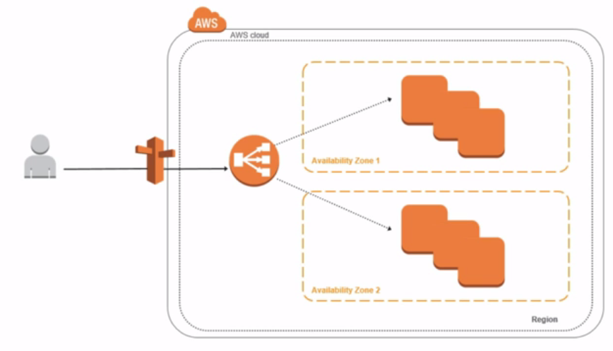

6.) Now in the event that you want more high availability, what you can do is deploy another elastic load balancer and have Route 53 point to that new elastic load balancer. In this case, now, you have two. So in the event that theoretically one should fail, the Route 53 will detect that via health checks, and what it will do is it will start to route the traffic to the other load balancer.

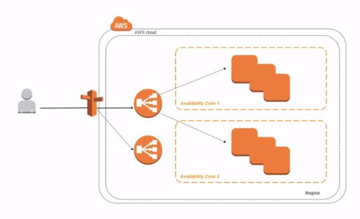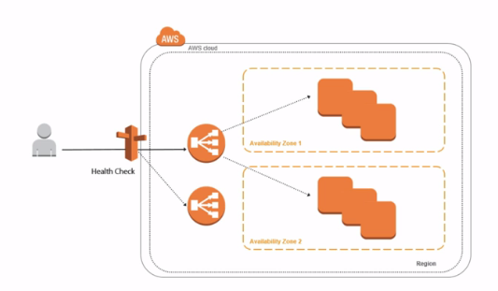

7.)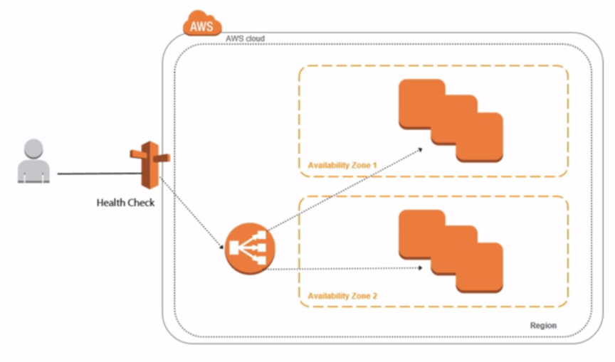

Now while this, again, and I say theoretically is correct and technically is also correct, the fact that elastic load balancer is a platform service and the fact that the architecture is not really exposed so we don't know how AWS is providing high availability, the likelihood of having a second ELB to be effective will probably be very small because if it's a software bug, it will probably affect both ELB instances. If it's some kind of a problem on the platform itself, again, it will probably affect both ELBs. So in this case, deploying another ELB may not be helpful. However, it is available to you. You can deploy multiple elastic load balancers to satisfy your high availability needs if you need to. Just remember that because this is a platform service, you are essentially trusting that AWS is doing the right thing and making the elastic load balancer highly available and scalable.

8.)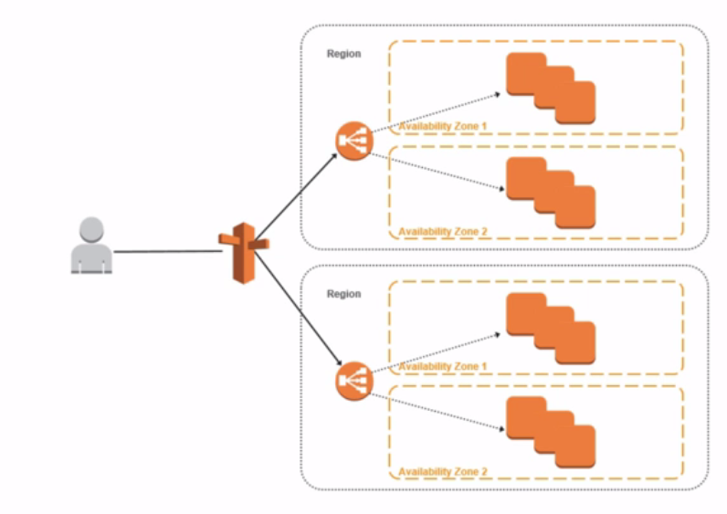

So we talked about the fact that you can leverage Route 53 to deploy centrally or to load balance across your load balancers. So this is geographic load balancing. I don't want to necessarily focus on that in this lesson. I want to focus on the capabilities of the elastic load balancer itself. We'll talk about how you do geographic load balancing in the Route 53 lesson when we go through the different algorithms that you can configure to point your users from the outside to one or more elastic load balancers depending on where they're connecting from in the world. So maybe you have a load balancer or maybe you have a region where your particular application is deployed in a particular language, let's say French, and you want to make sure that all of the French users are always directed to that particular load balancer or that particular region, then you can set that up in Route 53 to route that way. We'll talk about all of those. 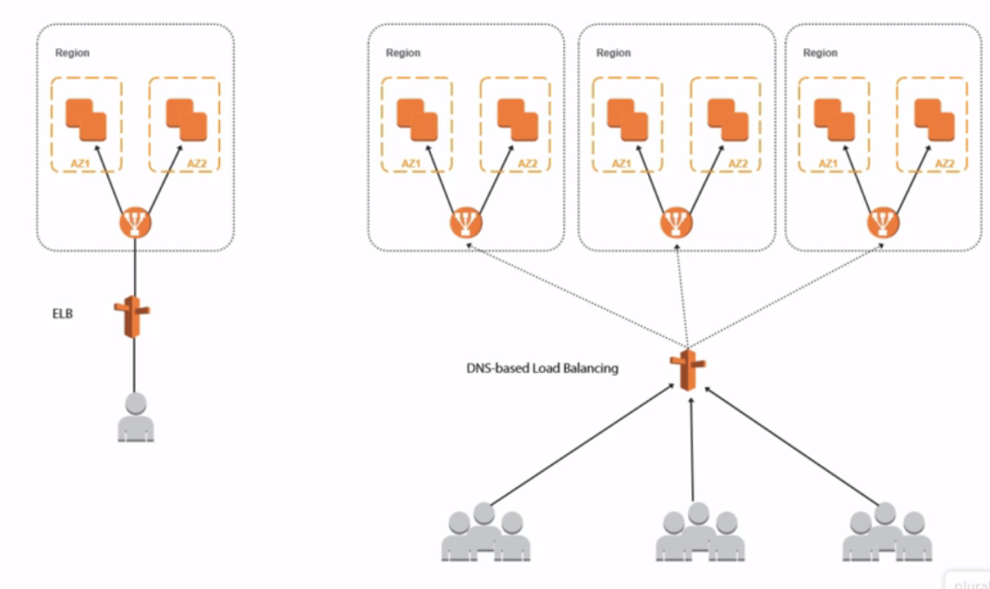

9.)I just wanted to give you an idea, and I also wanted to highlight that from a load balancing perspective, there is the traditional load balancing of instances, but there is also the geographically dispersed or the geographic load balancing that you can do. Now just to keep---and just to put things in perspective, you have the two options. So you have ELB. ELB specifically will either load balance internal instances or it will load balance extremal instances, external facing instances. That's elastic load balancing. That's what we're going to be focusing on and configuring in this lesson. Now you also have what we've just talked about is the cloud-based, DNS load balancing, which we're going to be covering later. So I just wanted to make sure that you see them side by side so that you know the difference and what we're going to be focusing on in this lesson versus what we're going to be focusing on in later lessons. Now without further ado, let's go ahead and jump in and configure elastic load balancer.

**Application ELB**

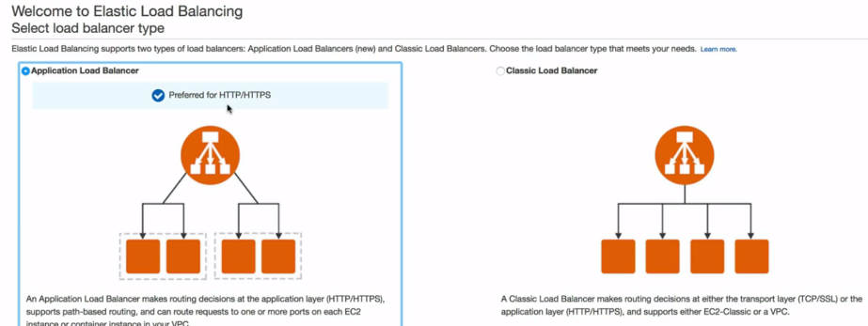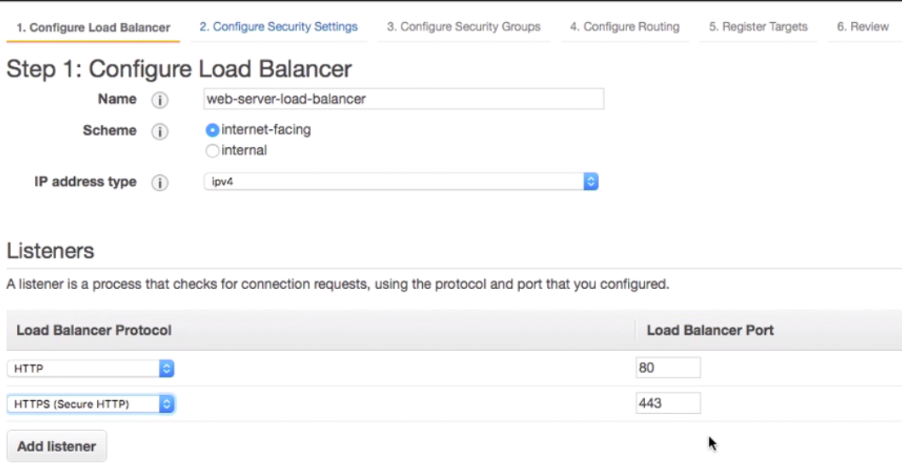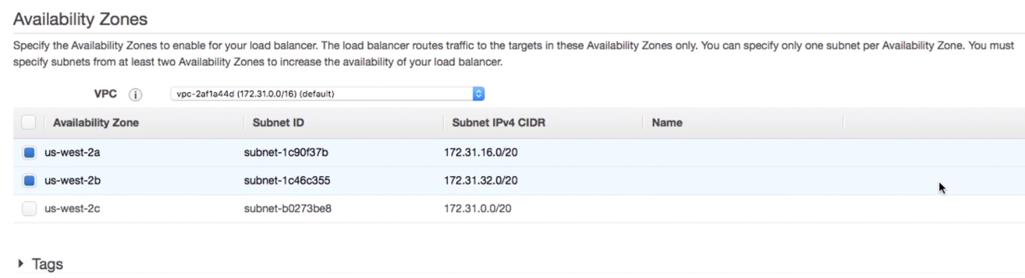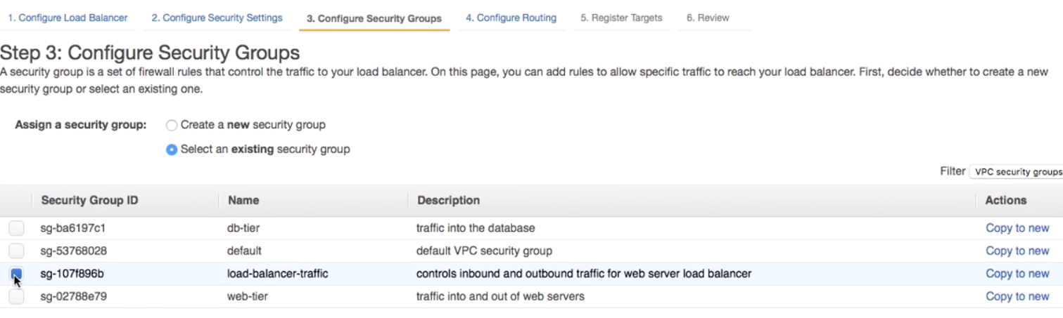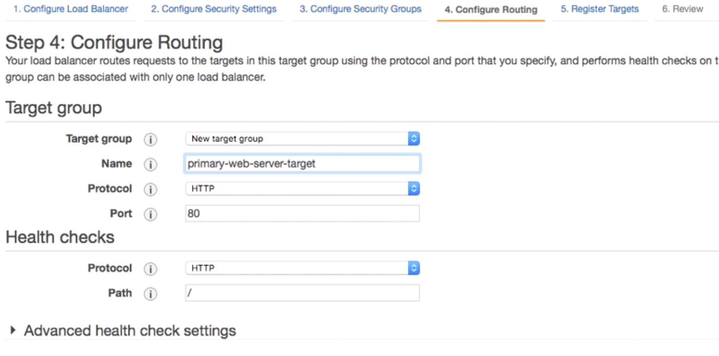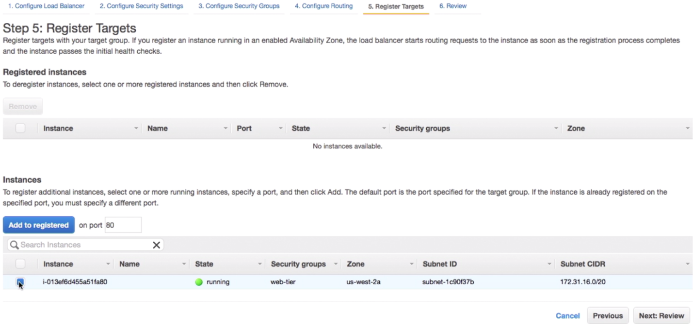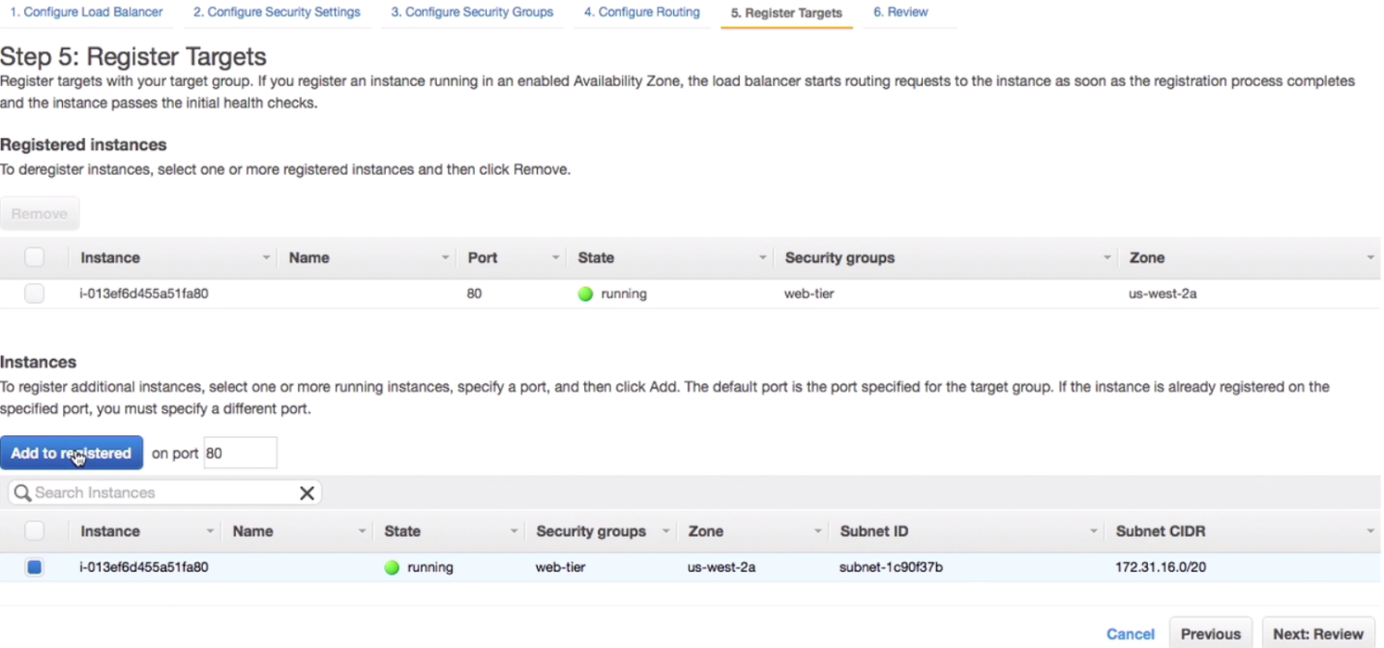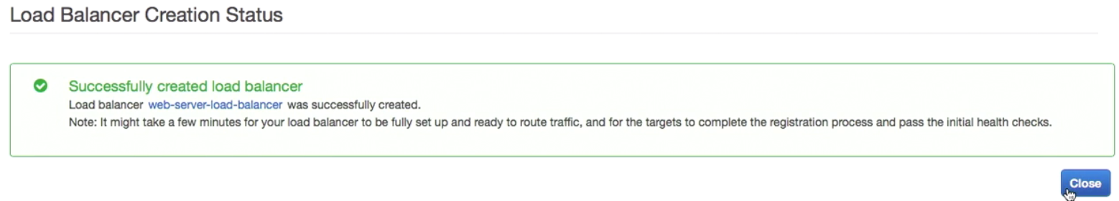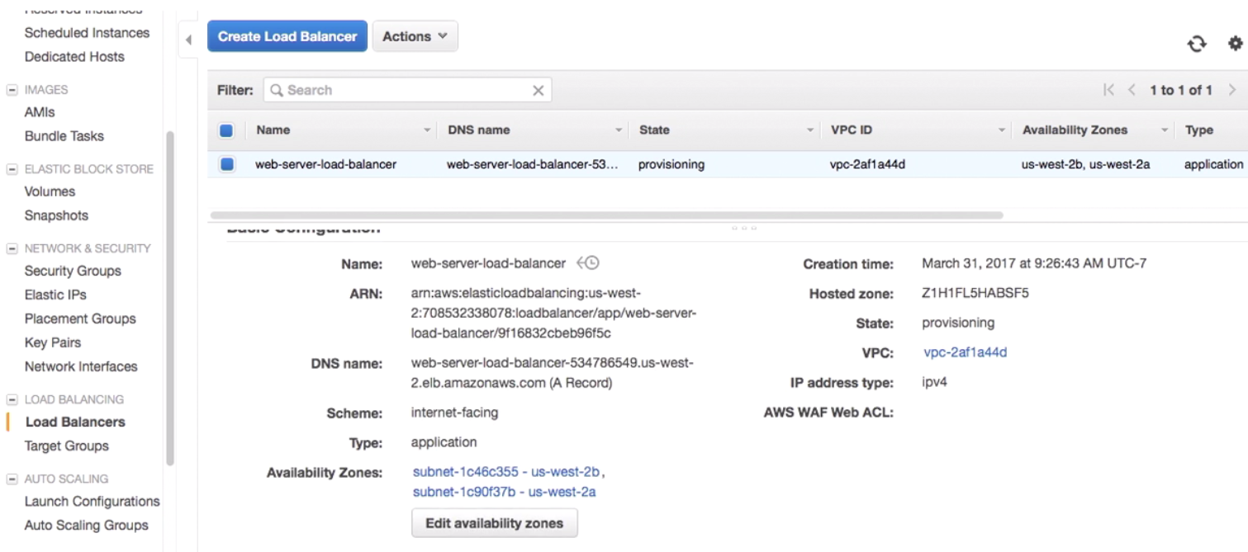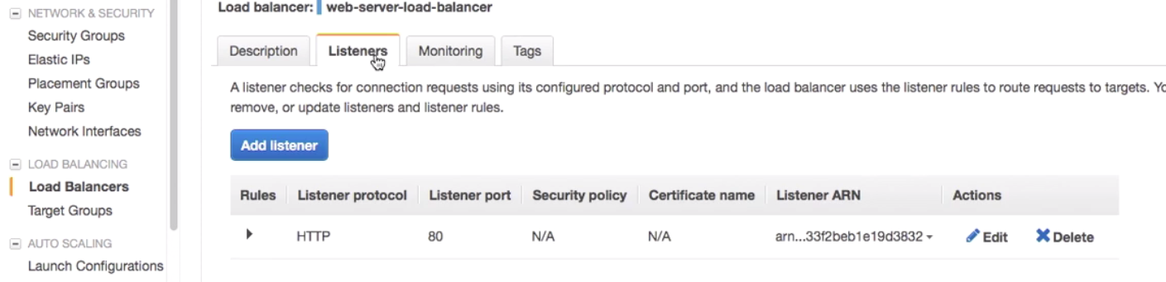

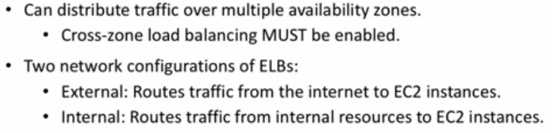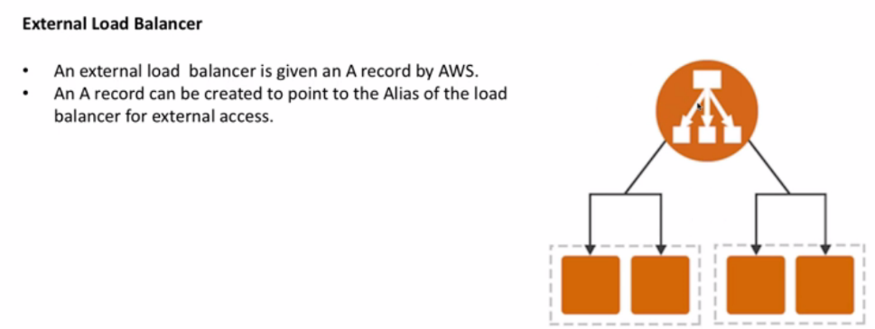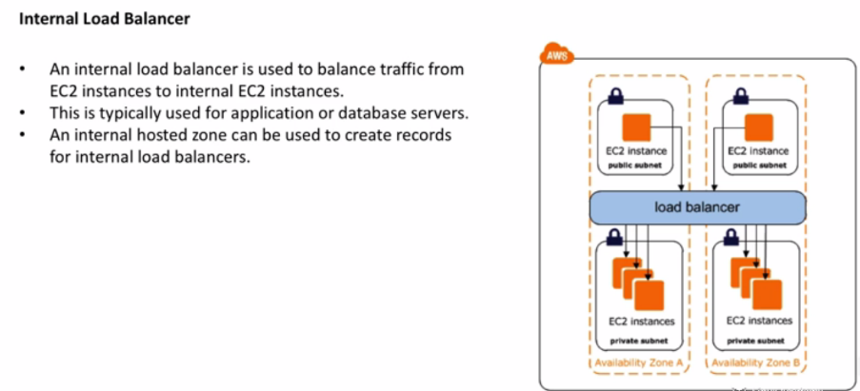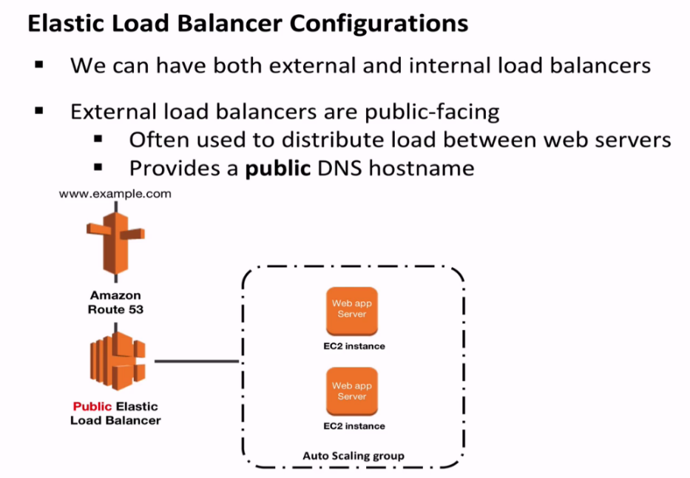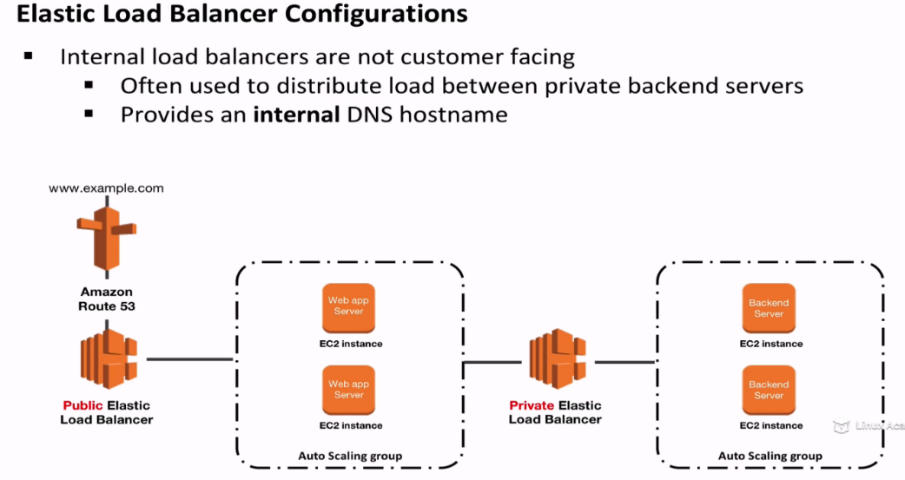

**Internal facing**

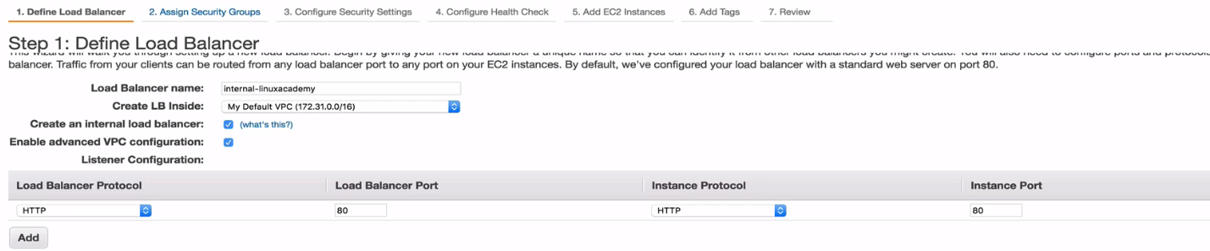

Select Private subnets only